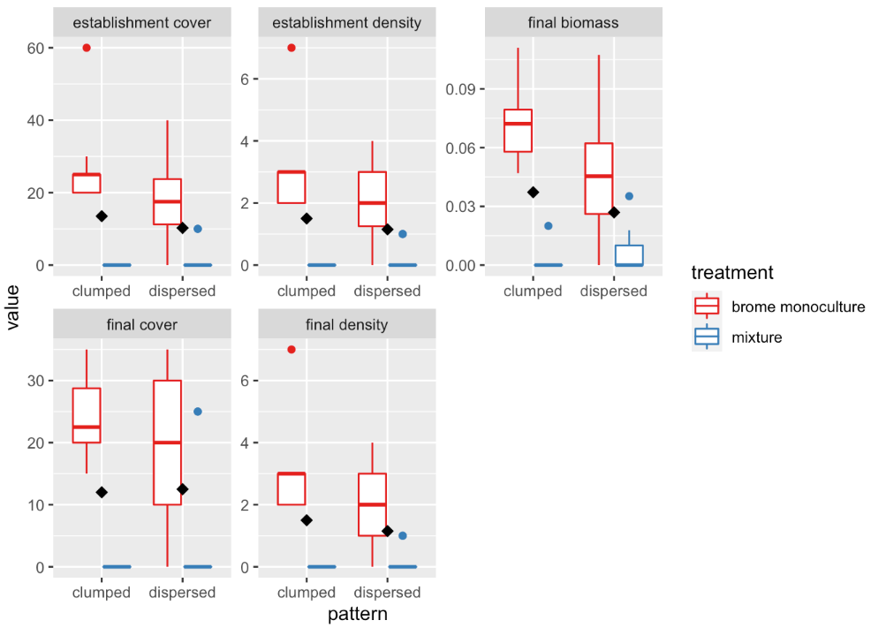**Figure 2.** Boxplots of measures percent cover (establishment and final; %), density (establishment and final census), and final biomass (g) of red brome monoculture and mixture treatments comparing two spatial patterns (clumped vs. dispersed). Diamond dots represent the mean. Establishment data was collected at week 4 and final data was collected at week 8.